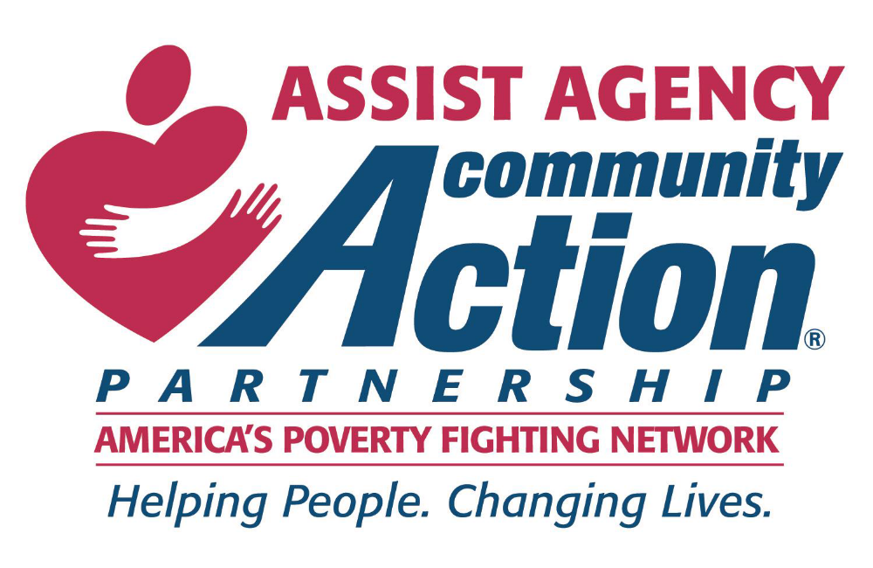

________________________________________________

Strategic Plan 2019-2023
________________________________________________

Revision 3 approved by the ASSIST Agency Incorporated Board of Directors November 15, 2021
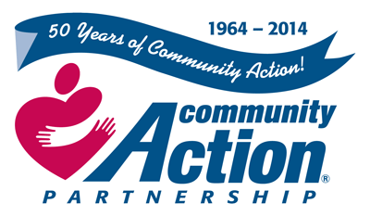

Table of Contents

Strategic Plan

Contents

Introduction

Strategic Planning Process

Community Assessment

ROMA

Organizational Profile

Assumptions

Accountability

GOAL ONE Consumer Input and Involvement

GOAL TWO Community Engagement

GOAL THREE Community Assessment

GOAL FOUR Organizational Leadership

GOAL FIVE Board Governance

GOAL SIX Strategic Planning

GOAL SEVEN Human Resource Management

GOAL EIGHT Financial Operations and Oversight

GOAL NINE Technology and Data Analysis

Legend

Summary
Introduction

Strategic Planning is a way for the ASSIST Agency to look back at where we have been, where we are now, and where the agency wants to be over the next 5 years. The development of a strategic plan is one of the requirements of the Community Services Block Grant (CSBG) Organizational Standards. The strategic planning process is an excellent way to implement an organizational assessment of the agency and to ask the important questions about the future path.

CSBG Eligible Entities are being required to achieve greater program accountability and measurable results. This Strategic Plan follows a core set of standards that to ensure that the agency will go beyond the basics of compliance and focus on high-quality performance and service delivery. The Board of Directors and staff focused on developing a strategic plan that would benefit the entire organization.

Strategic Planning Process

Phase One


The first phase of the planning process was to engage staff and board members in a conversation that would build a clear vision for the organization which would reflect on the historical perspective and still lean forward in order to develop a strategic plan covering the next five years. Key areas to be discussed were:
- consumer input and involvement,
- community engagement,
- community assessment,
- organizational leadership,
- board governance
- strategic planning,
- human resource management,
- financial operations and oversight,
- technology and data analysis

Phase Two

The second phase of the project served to define goals and objectives and establish a timeline for staff, board, and key partners, in order to implement the plan. The strategic plan will be implemented by a shared responsibility of staff, board, and key partners over a five-year period. The idea is to plan a process that is engaging and matches the capacity of the communities to be served as well as resources of staff and board. Without buy-in from these champions, a strategic plan becomes one more report on the shelf.

Community Assessment


The original assessment and the previous ASSIST Agency Strategic Plan, as well as additional research, was used to develop the strategic plan. An examination of the demographics, as well as future trends for the three parishes covered by ASSIST on poverty, employment, education, crime, and economic development was used in preparing the strategic plan. Research was also conducted with the National Association for State Community Service Programs (NASCSP), Community Action Partnership and CAPLAW to assess current requirements and future trends in order to give a clear focus for the agency.

A complete Community Needs Assessment was conducted in 2017 and approved by the Board of Directors that same year. Some of the data from that Assessment has been included into this Strategic Plan as well as the most current Customer Service Impact/Needs Survey.

The assessment concentrated on the causes and symptoms of poverty in the three parish area. The Customer Service Impact/Needs Survey was updated in September of 2017 to better ascertain the client’s needs and the barriers they are facing. 1,978 surveys were received in 2019, 1,443 surveys during the survey period of 2018 and 1,120 for the period 2017. The first part of the survey dealt with the demographics of the clients, which are as follows:
SEX 2019 2018 2017
- Female 1508 76.2% 1016 72.0% 71.5%
- Male 455 23.0% 383 27.1% 28.5%
- Other 15 0.8% 13 0.9%
RACE
- Black 1,058 53.0% 768 54.2% 52.6%
- White 874 43.8% 580 40.9% 44.1%
- Multi-race 21 1.1% 29 2.0% 0.9%
- Other 13 0.7% 23 1.6% 1.4%
- Native American 23 1.2% 13 0.9% 0.6%
- Asian 8 0.4% 4 0.3% 0.4%

ETHNICITY 2019 2018 2017
- Not Hispanic 1,974 98.8% 1,328 97.3% 96.8%
- Hispanic 24 1.2% 37 2.7% 3.2%
DISABLED
- No 1,549 77.6% 1120 84.7%
- Yes 448 22.4% 203 15.3%
AGES OF ADULTS IN HOUSEHOLD
- 25 – 44 621 31.4% 495 35.0%
- 65 – 74 353 17.8% 213 15.1%
- 45 – 54 239 12.1% 171 12.1%
- 60 – 64 259 13.1% 150 10.6%
- 18 – 24 163 8.2% 147 10.4%
- 55 – 59 183 9.2% 136 9.6%
- 75 + 158 8.0% 98 6.9%
EMPLOYED
- No 1,191 60.0% 743 53.1% 45.2%
- Yes 794 40.0% 657 46.9% 54.8%
ANNUAL HOUSEHOLD INCOME RANGE
- $ 5,001 – 10,000 503 25.0% 320 26.6%
- $10,001 – 15,000 340 16.9% 215 17.9%
- $20,001 – 25,000 169 8.4% 165 13.7%
- $15,001 – 20,000 161 8.0% 140 11.6%
- $ 1 – 5,000 98 4.9% 131 10.9%
- No Income 500 24.9% 82 6.8%
- $25,001 – 30,000 102 5.1% 53 4.4%
- $30,001 – 35,000 37 1.8% 34 2.8%
- $35,001 – 40,000 40 2.0% 33 2.7%
- $40,001 – 45,000 25 1.2% 13 1.4%
- $50,001 – 55,000 12 0.6% 9 0.7%
- $45,001 – 50,000 13 0.6% 3 0.2%
- $60,001 + 6 0.3% 3 0.2%
- $55,001 – 60,000 4 0.2% 2 0.2%

The next portion of the survey asked the question “Please check the following need(s) as they apply to you and/or your household”. Clients were even offered the opportunity to write in other needs if not listed (#47). The form was updated to include additional items that the clients reported on in the past but were listed under other or in too small of a sample to be reported on. The number of clients selecting that need and the corresponding percentage of the total assessment results are as follows:

SERVICES IDENTIFIED AS NEEDING 2019 2018 2017
- Income Tax Assistance 836 18.9% 689 13.5% 1 17.9%
- Utility Assistance 665 15.0% 468 9.2% 2 15.5%
- Toys for Tots 330 7.4% 316 6.2% 15 1.8%
- SNAP Benefits 201 4.5% 281 5.5% 29 0.2%
- Rental Assistance 208 4.7% 213 4.2% 3 7.8%
- Financial Counseling Services 143 3.2% 202 4.0% 25* 0.5%
- Dental Care 92 2.1% 190 3.7% 8 4.3%
- Vision Care 93 2.0% 179 3.5% 10 3.2%
- Health Insurance 81 1.8% 170 3.3%
- Job 119 2.7% 164 3.2% 5 7.4%
- Medicaid/LaCHIP 120 2.7% 161 3.2%
- Health Care 83* 1.9% 160 3.1% 6 6.3%
- Food 129 2.9% 156 3.1% 4 7.8%
- Apartment (Rental) 83* 1.9% 136* 2.7%
- LiHEAP 89 2.0% 136* 2.7%
- Medicine 98 2.2% 129 2.5% 7 4.3%
- Information/Referral 94 2.1% 112 2.2% 28 0.2%
- Housing 70 1.6% 98 1.9% 9 3.5%
- Job Search 67 1.5% 93 1.8%
- Clothing 87 2.0% 80* 1.6% 14 1.8%
- Transportation 75 1.7% 80* 1.6% 11 3.0%
- GED 48* 1.1% 70 1.4% 13 2.7%
- Job Training 61 1.4% 69 1.4% 12 2.8%
- Home Repair 48* 1.1% 64 1.3%
- Daycare – Child 19 0.4% 61 1.2% 25* 0.5%
- Tuition Assistance 32* 0.7% 60 1.2% 18 1.0%
- Vocational Training 27 0.6% 57 1.1%
- Medicare Assistance 37 0.8% 52 1.0%
- Education Expenses 24 0.5% 44 0.9%
- Housing Counseling Services 22* 0.5% 39 0.8%
- Resume Development 22* 0.5% 33 0.6%
- Rent Subsidy 34* 0.8% 32 0.6% 16 1.7%
- Interview Skills 94 2.1% 27 0.5%
- Summer Education Program 13* 0.3% 23 0.5%
- Mental Health 33 0.7% 22 0.4%
- Legal Services 34* 0.8% 20* 0.4% 24 0.5%
- After School Programs 12* 0.3% 20* 0.4%
- Voter registration 13* 0.3% 20* 0.4% 23 0.5%
- Career Counseling 8 0.2% 18* 0.4%
- Home Loan 15 0.3% 18* 0.4% 27 0.3%
- Eldercare – Adult 4* 0.1% 15* 0.3%
- Substance Abuse Assistance 3* 0.1% 15* 0.3% 17 1.1%
- Mortgage Assistance 23 0.5% 13* 0.3% 19 1.0%
- Independent-living Home Imp 20 0.5% 13* 0.3%
- Domestic Violence Protection 5* 0.1% 12* 0.2% 21 0.9%
- Permanent Supportive Housing 12* 0.3% 12* 0.2%
- Auto/Homeowners Insurance 5* 0.1% 10 0.2%
- IDA 2 0.0% 8* 0.2%
- Healthy Home Services 14 0.3% 8* 0.2%
- TANF Benefits 11 0.2% 7 0.1%
- Business Loan 4* 0.1% 6* 0.1% 30 0.1%
- Emergency Shelter 32* 0.7% 6* 0.1% 19 0.6%
- Business Plan 3* 0.1% 5* 0.1%
- Handicap Ramp 3* 0.1% 5* 0.1%
- Weatherization 7 0.2% 3 0.1%
- Disaster/Emergency Assistance 3* 0.1% 2 0.0% 20 0.9%

The finale survey question asked the clients to rank the causes, symptoms and/or needs that are barriers to them becoming self-sufficient. This survey compares the results from the 2014 Strategic Plan. Please note that the 2017 survey only had 18 questions and #12, “Nutritional Needs,” was combined into “High costs of food” with the new survey. The results are as follows:

2019 2018 2017
- High costs of energy 22.9% 1 18.5% 1 29.5%
- High costs of food 14.0% 2 12.1% 6 6.2%
- Low paying jobs 7.2% 4 7.9% 4 7.0%
- Lack of affordable housing 7.7% 3 8.1% 2 10.9%
- Lack of jobs 7.8% 5 10.0% 3 10.0%
- Lack of Financial/Budget Skills 5.1% 6 6.0% -
- Lack of affordable health care 4.2% 7 5.4% 8 5.4%
- High costs of housing upkeep 3.7% 10 3.6% -
- Lack of transportation 3.7% 12 3.6% 10 3.6%
- Lack of job skills 3.4% 9 3.7 9 4.8%
- Lack of higher education 3.3% 11 3.6% 7 5.8%
- High cost of clothing 2.7% 15 2.5% 14 1.3%
- Lack of health insurance 2.5% 8 4.3% -
- Mental Health issues 2.5% 17 1.2% -
- High school dropout 2.2% 14 2.7% 13 1.4%
- Lack of health care 2.0% 13 2.9% 5 6.9%
- High cost of child care 1.6% 16 2.0% 18 0.3%
- Crime victim 1.0% 21 0.7% 16 0.9%
- Substance abuse 0.9% 20 0.8% 17 0.8%
- Domestic violence 0.9% 18 1.1% 11 2.1%
- Teen pregnancy 0.7% 19 0.9% 15 1.2%

The second survey conducted for the Community Needs Assessment was a community wide survey which included Board Members, Community Based Organizations, Educational Institutions, faith-based Organizations, Private Organizations and the Public Sector. The second question was what are the most pressing needs of the community and to list the top five unmet needs. The response was very broad but some responses were repeated several times. The top responses included

- Affordable Housing 13.0%
- Transportation 13.0%
- Food 10.9%
- Jobs 8.7%
- Homeless Shelter 6.5%
- Health Care 6.5%
- Mental Health Services 6.5%
- Utility Assistance 4.3%
- GED 4.3%
- After School Programs 4.3%
- Financial Assistance 2.2%
- Legal Assistance 2.2%
- Supportive Services 2.2%
- Prescription Medications 2.2%
- Parenting Skills Classes 2.2%
- Behavioral Issues with Children 2.2%
- Financial Education 2.2%
- Interview Skills 2.2%
- Life Coaching 2.2%
- Substance Abuse Assistance 2.2%

The next question requested identifying any organization or government entity that is addressing these issues. The response listed 15 organizations that is helping the low-income clients with a variety of services. The ASSIST Agency has worked and/or is working with all of them at one time or another.

The final question asked for recommendations regarding the types of services that would help meet the needs identified or any other unmet need. Only two items made the list more than once, transportation and a Community garden. All of the suggested services are areas our agency currently addresses directly or through referral.

Customer Satisfaction Survey Assessment

The ASSIST Agency clients were asked to evaluate the services they received as part of the strategic plan. This survey is conducted on a regular basis and presented to the board for approval annually. The most current results indicated an overall score of 97% approval rating with the individual staff scores ranging from a low of 95% to a high of 99%.

Community Needs Assessment (Community Commons)

Community Needs Indicators Report
Report Area
Acadia Parish, LA; Jefferson Davis Parish, LA; Vermilion Parish, LA
Data Category
Demographics | Social Economic Factors | Physical Environment | Clinical Care
Demographics
Current population demographics and changes in demographic composition over time play a determining role in the types of health and social services needed by communities.
Data Indicators
- Total Population

Total Population
A total of 153,295 people live in the 2,479.70 square mile report area defined for this assessment according to the U.S. Census Bureau American Community Survey 2012-16 5-year estimates. The population density for this area, estimated at 61.82 persons per square mile, is less than the national average population density of 90.19 persons per square mile.
Report Area | Total Population | Total Land Area  (Square Miles) | Population Density  (Per Square Mile)
Report Area | 153,295 | 2,479.70 | 61.82
Acadia Parish, LA | 62,372 | 655.13 | 95.21
Jefferson Davis Parish, LA | 31,399 | 651.36 | 48.2
Vermilion Parish, LA | 59,524 | 1,173.21 | 50.74
Louisiana | 4,645,670 | 43,206.73 | 107.52
United States | 318,558,162 | 3,532,068.58 | 90.19
Data Source: US Census Bureau, American Community Survey. 2012-16. Source geography: Tract
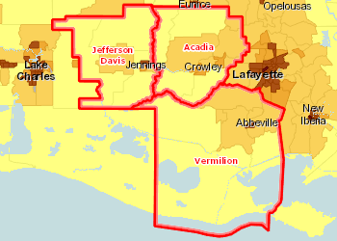 | Population, Density (Persons per Sq Mile) by Tract, ACS 2012-16  Over 5,000  1,001 - 5,000  501 - 1,000  51 - 500  Under 51  No Data or Data Suppressed  Report Area
Total Population by Gender
Report Area | Male | Female | Percent Male | Percent Female
Report Area | 74,404 | 78,891 | 48.54% | 51.46%
Acadia Parish, LA | 30,297 | 32,075 | 48.57% | 51.43%
Jefferson Davis Parish, LA | 15,351 | 16,048 | 48.89% | 51.11%
Vermilion Parish, LA | 28,756 | 30,768 | 48.31% | 51.69%
Louisiana | 2,271,684 | 2,373,986 | 48.9% | 51.1%
United States | 156,765,322 | 161,792,840 | 49.21% | 50.79%

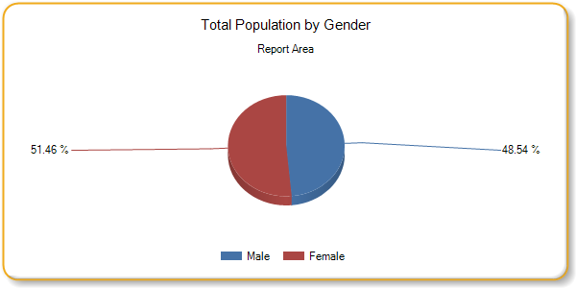

Total Population by Age Groups, Total
Report Area | Age 0-4 | Age 5-17 | Age 18-24 | Age 25-34 | Age 35-44 | Age 45-54 | Age 55-64 | Age 65
Report Area | 10,839 | 29,578 | 13,324 | 19,810 | 18,065 | 20,890 | 19,328 | 21,461
Acadia | 4,542 | 12,185 | 5,576 | 8,250 | 7,289 | 8,321 | 7,781 | 8,428
Jeff Davis | 2,123 | 5,898 | 2,719 | 3,937 | 3,590 | 4,317 | 4,017 | 4,798
Vermilion | 4,174 | 11,495 | 5,029 | 7,623 | 7,186 | 8,252 | 7,530 | 8,235
Louisiana | 309,257 | 804,765 | 465,669 | 666,210 | 569,307 | 610,677 | 586,060 | 633,725
United States | 19,866,960 | 53,745,478 | 31,296,577 | 43,397,907 | 40,548,400 | 43,460,466 | 40,061,742 | 46,180,632
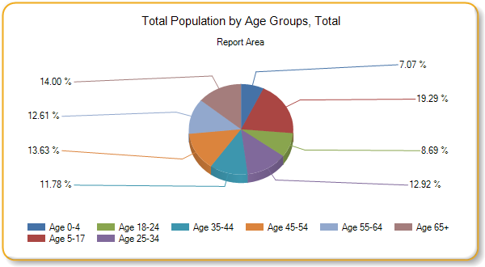
Total Population by Age Groups, Percent
Report Area | Age 0-4 | Age 5-17 | Age 18-24 | Age 25-34 | Age 35-44 | Age 45-54 | Age 55-64 | Age 65
Report Area | 7.07% | 19.29% | 8.69% | 12.92% | 11.78% | 13.63% | 12.61% | 14%
Acadia Parish, LA | 7.28% | 19.54% | 8.94% | 13.23% | 11.69% | 13.34% | 12.48% | 13.51%
Jeff Davis Parish, LA | 6.76% | 18.78% | 8.66% | 12.54% | 11.43% | 13.75% | 12.79% | 15.28%
Vermilion Parish, LA | 7.01% | 19.31% | 8.45% | 12.81% | 12.07% | 13.86% | 12.65% | 13.83%
Louisiana | 6.66% | 17.32% | 10.02% | 14.34% | 12.25% | 13.15% | 12.62% | 13.64%
United States | 6.24% | 16.87% | 9.82% | 13.62% | 12.73% | 13.64% | 12.58% | 14.5%
Total Population by Race Alone, Total
Report Area | White | Black | Asian | Native American / Alaska Native | Native Hawaiian / Pacific Islander | Some Other Race | Multiple Races
Report Area | 122,841 | 24,766 | 1,499 | 554 | 15 | 849 | 2,771
Acadia Parish | 49,287 | 11,168 | 61 | 27 | 15 | 634 | 1,180
Jeff Davis Parish | 25,191 | 5,177 | 107 | 215 | 0 | 53 | 656
Vermilion Parish | 48,363 | 8,421 | 1,331 | 312 | 0 | 162 | 935
Louisiana | 2,909,290 | 1,494,201 | 78,719 | 26,403 | 1,464 | 50,434 | 85,159
United States | 233,657,078 | 40,241,818 | 16,614,625 | 2,597,817 | 560,021 | 15,133,856 | 9,752,947

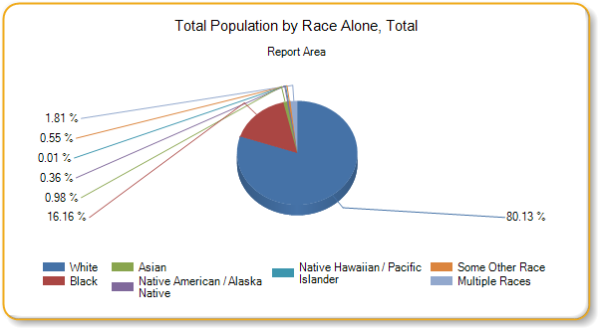
Total Population by Race Alone, Percent
Report Area | White | Black | Asian | Native American / Alaska Native | Native Hawaiian / Pacific Islander | Some Other Race | Multiple Races
Report Area | 80.13% | 16.16% | 0.98% | 0.36% | 0.01% | 0.55% | 1.81%
Acadia Parish, LA | 79.02% | 17.91% | 0.1% | 0.04% | 0.02% | 1.02% | 1.89%
Jefferson Davis Parish, LA | 80.23% | 16.49% | 0.34% | 0.68% | 0% | 0.17% | 2.09%
Vermilion Parish, LA | 81.25% | 14.15% | 2.24% | 0.52% | 0% | 0.27% | 1.57%
Louisiana | 62.62% | 32.16% | 1.69% | 0.57% | 0.03% | 1.09% | 1.83%
United States | 73.35% | 12.63% | 5.22% | 0.82% | 0.18% | 4.75% | 3.06%

Total Population by Ethnicity Alone
Report Area | Total Population | Hispanic or Latino Population | Percent Population Hispanic or Latino | Non-Hispanic Population | Percent Population Non-Hispanic
Report Area | 153,295 | 3,919 | 2.56% | 149,376 | 97.44%
Acadia Parish | 62,372 | 1,362 | 2.18% | 61,010 | 97.82%
Jeff Davis Parish | 31,399 | 679 | 2.16% | 30,720 | 97.84%
Vermilion Parish | 59,524 | 1,878 | 3.16% | 57,646 | 96.84%
Louisiana | 4,645,670 | 223,408 | 4.81% | 4,422,262 | 95.19%
U. S. | 318,558,162 | 55,199,107 | 17.33% | 263,359,055 | 82.67%

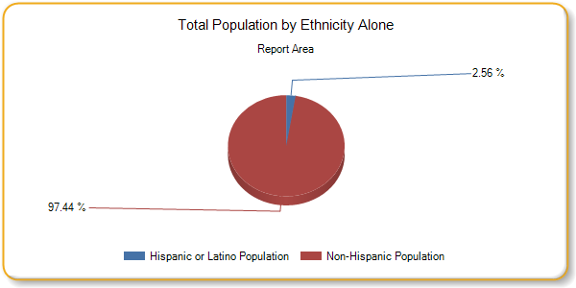
Hispanic Population by Race Alone, Total
Report Area | White | Black | Asian | Native American / Alaska Native | Native Hawaiian / Pacific Islander | Some Other Race | Multiple Races
Report Area | 2,860 | 53 | 6 | 61 | 0 | 743 | 196
Acadia Parish, LA | 778 | 6 | 0 | 0 | 0 | 546 | 32
Jeff Davis Parish, LA | 531 | 10 | 0 | 61 | 0 | 35 | 42
Vermilion Parish, LA | 1,551 | 37 | 6 | 0 | 0 | 162 | 122
Louisiana | 154,647 | 10,295 | 456 | 2,353 | 200 | 42,871 | 12,586
United States | 36,294,406 | 1,143,499 | 189,308 | 513,491 | 51,097 | 14,457,853 | 2,549,453
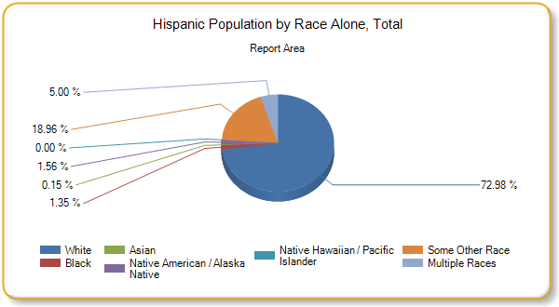
Non-Hispanic Population by Race Alone, Total
Report Area | White | Black | Asian | Native American / Alaska Native | Native Hawaiian / Pacific Islander | Some Other Race | Multiple Races
Report Area | 119,981 | 24,713 | 1,493 | 493 | 15 | 106 | 2,575
Acadia Parish | 48,509 | 11,162 | 61 | 27 | 15 | 88 | 1,148
Jefferson Davis Parish | 24,660 | 5,167 | 107 | 154 | 0 | 18 | 614
Vermilion Parish | 46,812 | 8,384 | 1,325 | 312 | 0 | 0 | 813
Louisiana | 2,754,643 | 1,483,906 | 78,263 | 24,050 | 1,264 | 7,563 | 72,573
United States | 197,362,672 | 39,098,319 | 16,425,317 | 2,084,326 | 508,924 | 676,003 | 7,203,494

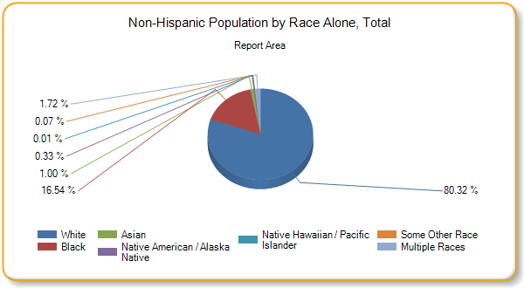
Non-Hispanic Population by Race Alone, Percent
Report Area | White | Black | Asian | Native American / Alaska Native | Native Hawaiian / Pacific Islander | Some Other Race | Multiple Races
Report Area | 80.32% | 16.54% | 1% | 0.33% | 0.01% | 0.07% | 1.72%
Acadia Parish | 79.51% | 18.3% | 0.1% | 0.04% | 0.02% | 0.14% | 1.88%
Jefferson Davis Parish | 80.27% | 16.82% | 0.35% | 0.5% | 0% | 0.06% | 2%
Vermilion Parish | 81.21% | 14.54% | 2.3% | 0.54% | 0% | 0% | 1.41%
Louisiana | 62.29% | 33.56% | 1.77% | 0.54% | 0.03% | 0.17% | 1.64%
United States | 74.94% | 14.85% | 6.24% | 0.79% | 0.19% | 0.26% | 2.74%

Social Economic Factors
Economic and social insecurity often are associated with poor health. Poverty, unemployment, and lack of educational achievement affect access to care and a community’s ability to engage in healthy behaviors. Without a network of support and a safe community, families cannot thrive. Ensuring access to social and economic resources provides a foundation for a healthy community.
Food Insecurity Rate
This indicator reports the estimated percentage of the population that experienced food insecurity at some point during the report year. Food insecurity is the household-level economic and social condition of limited or uncertain access to adequate food.
Data Source: Feeding America. 2014. Source geography: County | Percentage of Total Population with Food Insecurity  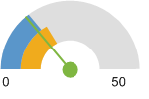  Report Area (13.91)  Louisiana (17.3)  United States (14.91)
  Report Area | Total Population | Food Insecure Population, Total | Food Insecurity Rate
  Report Area | 152,307 | 21,190 | 13.91%
  Acadia Parish, LA | 62,031 | 9,160 | 14.77%
  Jefferson Davis Parish, LA | 31,492 | 4,540 | 14.42%
  Vermilion Parish, LA | 58,784 | 7,490 | 12.74%
  Louisiana | 4,649,676 | 804,500 | 17.3%
  United States | 318,198,163 | 47,448,890 | 14.91%

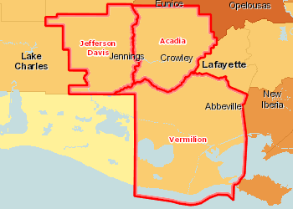 | Food Insecure Population, Percent by County, Feeding America 2014  Over 18.0%  15.1 - 18.0%  12.1 - 15.0%  Under 12.1%  Report Area
Food Insecurity - Food Insecure Children
This indicator reports the estimated percentage of the population under age 18 that experienced food insecurity at some point during the report year. Food insecurity is the household-level economic and social condition of limited or uncertain access to adequate food.
Report Area | Population Under Age 18 | Food Insecure Children, Total | Child Food Insecurity Rate
Report Area | 40,554 | 9,460 | 23.33%
Acadia Parish, LA | 16,719 | 3,880 | 23.21%
Jefferson Davis Parish, LA | 8,265 | 1,910 | 23.11%
Vermilion Parish, LA | 15,570 | 3,670 | 23.57%
Louisiana | 1,112,674 | 271,500 | 24.4%
United States | 73,580,326 | 17,284,530 | 23.49%
High School Graduation Rate (EdFacts)
Within the report area 89.6% of students are receiving their high school diploma within four years. Data represents the 2015-16 school year.
This indicator is relevant because research suggests education is one the strongest predictors of health (Freudenberg Ruglis, 2007).
Data Source: US Department of Education, EDFacts. Accessed via DATA.GOV. Additional data analysis by CARES. 2015-16. Source geography: School District | Cohort Graduation Rate  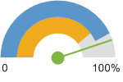  Report Area (89.6%)  Louisiana (79.7%)  United States (86.1%)
  Report Area | Total Student Cohort | Estimated Number of Diplomas Issued | Cohort Graduation Rate
  Report Area | 1,533 | 1,373 | 89.6
  Acadia Parish | 591 | 508 | 86
  Jefferson Davis Parish | 388 | 361 | 93
  Vermilion Parish | 554 | 504 | 91
  Louisiana | 43,146 | 34,367 | 79.7
  United States | 3,135,216 | 2,700,120 | 86.1

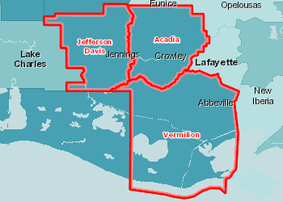 | On-Time Graduation, Rate by School District (Secondary), EDFacts 2015-16  Over 94.0%  85.1 - 94.0%  75.1 - 85.0%  Under 75.1%  No Data or Data Suppressed  Report Area
Income - Median Family Income
This indicator reports median family income based on the latest 5-year American Community Survey estimates. A family household is any housing unit in which the householder is living with one or more individuals related to him or her by birth, marriage, or adoption. Family income includes the incomes of all family members age 15 and older.
Data Source: US Census Bureau, American Community Survey. 2012-16. | Median Family Income  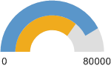  Louisiana (58,068)  United States (67,871)
  Report Area | Total Family Households | Average Family Income | Median Family Income
  Report Area | 38,572 | $67,864 | no data
  Acadia Parish | 15,583 | $63,626 | $48,031
  Jefferson Davis Parish | 7,914 | $71,625 | $54,384
  Vermilion Parish | 15,075 | $70,270 | $58,338
  Louisiana | 1,122,841 | $77,509 | $58,068
  United States | 77,608,829 | $90,960 | $67,871

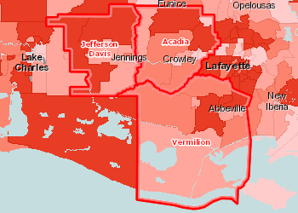 | Median Family Income by Tract, ACS 2012-16  Over $65,000  $55,001 - $65,000  $45,001 - $55,000  Under $45,001  No Data or Data Suppressed  Report Area
Median Family Income by Family Composition
Report Area | Married-Couple Families without Children | Married-Couple Families with Children | Single-Males without Children | Single-Males with Children | Single Females without Children | Single Females with Children
Report Area | no data | no data | no data | no data | no data | no data
Acadia Parish | $52,052 | $75,844 | $46,250 | $45,163 | $21,636 | $20,346
Jeff Davis Parish | $67,471 | $89,571 | $45,446 | $40,727 | $31,736 | $18,566
Vermilion Parish | $60,286 | $88,045 | $32,986 | $45,799 | $42,439 | $23,214
Louisiana | $70,267 | $87,552 | $46,763 | $40,725 | $34,805 | $19,877
United States | $78,162 | $87,757 | $53,570 | $39,618 | $44,636 | $25,130
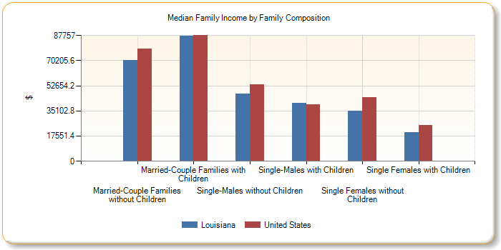
Median Family Income by Race / Ethnicity of Householder
Report Area | Non-Hispanic White | Black | Asian | American Indian / Alaska Native | Native Hawaiian / Pacific Islander | Other Race | Multiple Race | Hispanic / Latino
Report Area | no data | no data | no data | no data | no data | no data | no data | no data
Acadia Parish | $55,165 | $26,232 | no data | no data | no data | $62,500 | no data | $32,143
Jeff Davis Parish | $59,297 | $29,475 | $250,001 | $177,639 | no data | no data | no data | no data
Vermilion Parish | $63,197 | $32,179 | $70,875 | $130,333 | no data | no data | $12,108 | $51,950
Louisiana | $71,957 | $34,595 | $65,512 | $54,427 | $64,333 | $44,185 | $49,035 | $47,674
United States | $76,714 | $44,531 | $87,834 | $45,004 | $58,915 | $42,588 | $59,092 | $46,249
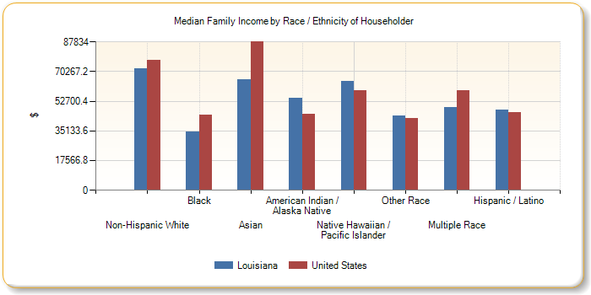
Insurance - Population Receiving Medicaid
This indicator reports the percentage of the population with insurance enrolled in Medicaid (or other means-tested public health insurance). This indicator is relevant because it assesses vulnerable populations which are more likely to have multiple health access, health status, and social support needs; when combined with poverty data, providers can use this measure to identify gaps in eligibility and enrollment.
Data Source: US Census Bureau, American Community Survey. 2012-16. Source geo: Tract | Percent of Insured Population Receiving Medicaid  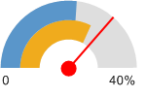  Report Area (29.14%)  Louisiana (26.17%)  United States (21.62%)
  Report Area | Total Population  (For Whom Insurance Status is Determined) | Population with Any Health Insurance | Population Receiving Medicaid | Percent of Insured Population Receiving Medicaid
  Report Area | 151,426 | 130,371 | 37,995 | 29.14%
  Acadia Parish | 61,470 | 51,870 | 15,528 | 29.94%
  Jeff Davis Parish | 30,881 | 27,216 | 8,563 | 31.46%
  Vermilion Parish | 59,075 | 51,285 | 13,904 | 27.11%
  Louisiana | 4,542,312 | 3,901,152 | 1,020,819 | 26.17%
  United States | 313,576,137 | 276,875,891 | 59,874,221 | 21.62%

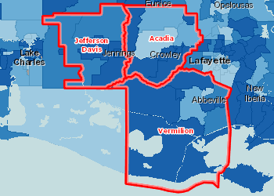 | Insured, Medicaid / Means-Tested Coverage, Percent by Tract, ACS 2012-16  Over 25,0%  20.1 - 25.0%  15.1 - 20.0%  Under 15.1%  No Data or Data Suppressed  Report Area
Population Receiving Medicaid by Age Group, Percent
Report Area | Under Age 18 | Age 18 - 64 | Age 65
Report Area | 52.21% | 14.71% | 17.56%
Acadia Parish, LA | 51.19% | 14.74% | 19.5%
Jefferson Davis Parish, LA | 62.58% | 14.38% | 20.11%
Vermilion Parish, LA | 47.98% | 14.84% | 14.11%
Louisiana | 49.18% | 13.17% | 16.79%
United States | 38.48% | 12.99% | 13.92%
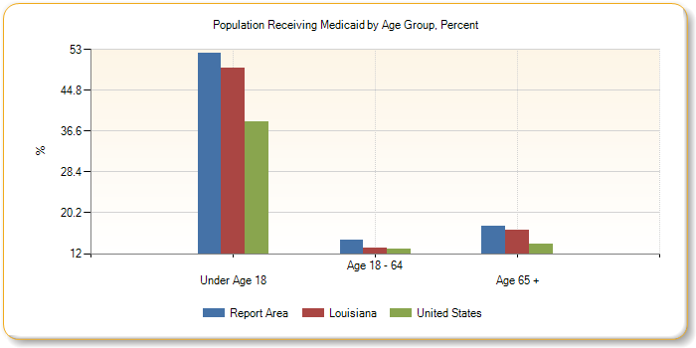
Population Receiving Medicaid by Age Group, Total
Report Area | Under Age 18 | Age 18 - 64 | Age 65
Report Area | 21,086 | 13,356 | 3,553
Acadia Parish, LA | 8,551 | 5,428 | 1,549
Jefferson Davis Parish, LA | 5,017 | 2,641 | 905
Vermilion Parish, LA | 7,518 | 5,287 | 1,099
Louisiana | 546,989 | 370,930 | 102,900
United States | 28,274,361 | 25,352,667 | 6,247,193
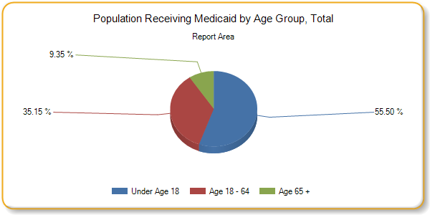
Insurance - Uninsured Population
The lack of health insurance is considered a key driver of health status.
This indicator reports the percentage of the total civilian non-institutionalized population without health insurance coverage. This indicator is relevant because lack of insurance is a primary barrier to healthcare access including regular primary care, specialty care, and other health services that contributes to poor health status.
Data Source: US Census Bureau, American Community Survey. 2012-16. | Percent Uninsured Population  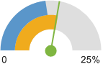  Report Area (13.9%)  Louisiana (14.12%)  United States (11.7%)
  Report Area | Total Population  (For Whom Insurance Status is Determined) | Total Uninsured Population | Percent Uninsured Population
  Report Area | 151,426 | 21,055 | 13.9%
  Acadia Parish | 61,470 | 9,600 | 15.62%
  Jeff Davis Parish | 30,881 | 3,665 | 11.87%
  Vermilion Parish | 59,075 | 7,790 | 13.19%
  Louisiana | 4,542,312 | 641,160 | 14.12%
  U. S. | 313,576,137 | 36,700,246 | 11.7%

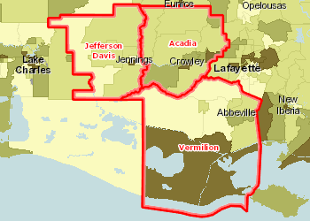 | Uninsured Population, Percent by Tract, ACS 2012-16  Over 20.0%  15.1 - 20.0%  10.1 - 15.0%  Under 10.1%  No Data or Data Suppressed  Report Area
Uninsured Population by Gender
Report Area | Total Male | Total Female | Percent Male | Percent Female
Report Area | 10,131 | 10,924 | 13.77% | 14.03%
Acadia Parish, LA | 4,391 | 5,209 | 14.7% | 16.48%
Jefferson Davis Parish, LA | 1,627 | 2,038 | 10.83% | 12.85%
Vermilion Parish, LA | 4,113 | 3,677 | 14.34% | 12.1%
Louisiana | 332,626 | 308,534 | 15.19% | 13.12%
United States | 19,759,421 | 16,940,825 | 12.9% | 10.56%
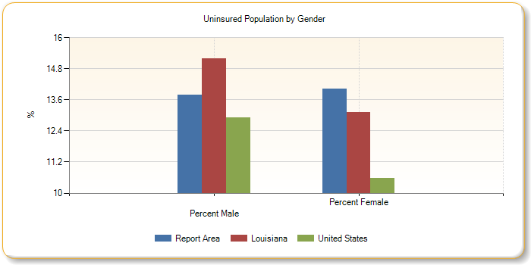
Uninsured Population by Age Group, Percent
Report Area | Under Age 18 | Age 18 - 64 | Age 65
Report Area | 3.31% | 21.64% | 0.33%
Acadia Parish, LA | 4.27% | 24.03% | 0.49%
Jefferson Davis Parish, LA | 1.83% | 19.13% | 0.13%
Vermilion Parish, LA | 3.03% | 20.48% | 0.27%
Louisiana | 4.78% | 20.74% | 0.62%
United States | 5.9% | 16.37% | 0.91%
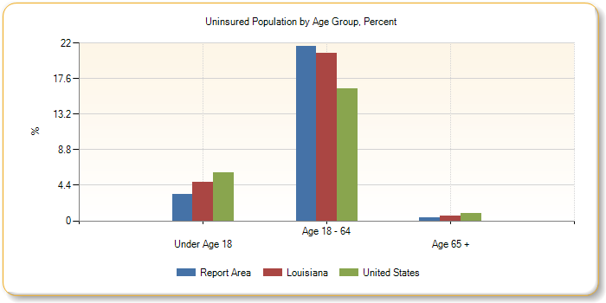
Uninsured Population by Age Group, Total
Report Area | Under Age 18 | Age 18 - 64 | Age 65
Report Area | 1,336 | 19,653 | 66
Acadia Parish, LA | 714 | 8,847 | 39
Jefferson Davis Parish, LA | 147 | 3,512 | 6
Vermilion Parish, LA | 475 | 7,294 | 21
Louisiana | 53,120 | 584,244 | 3,796
United States | 4,333,068 | 31,960,240 | 406,938
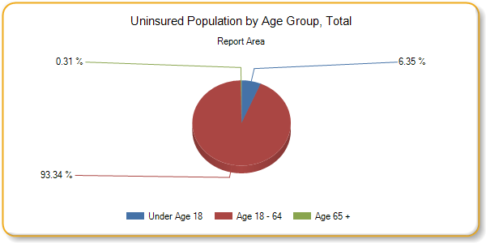
Uninsured Population by Ethnicity Alone
Report Area | Total Hispanic / Latino | Total Not Hispanic / Latino | Percent Hispanic / Latino | Percent Not Hispanic or Latino
Report Area | 1,387 | 19,668 | 35.84% | 13.33%
Acadia Parish, LA | 711 | 8,889 | 53.1% | 14.78%
Jefferson Davis Parish, LA | 91 | 3,574 | 13.4% | 11.83%
Vermilion Parish, LA | 585 | 7,205 | 31.59% | 12.59%
Louisiana | 70,723 | 570,437 | 32.58% | 13.19%
United States | 12,756,229 | 23,944,017 | 23.42% | 9.24%

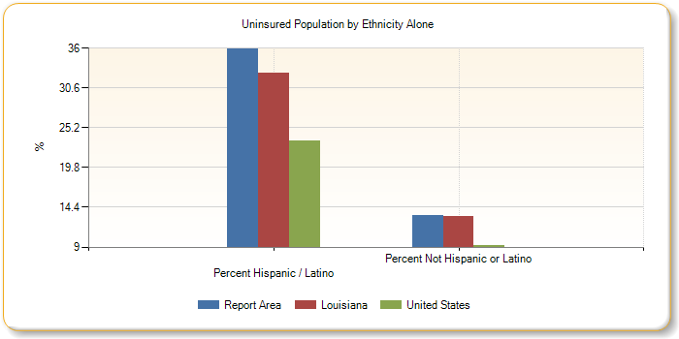
Uninsured Population by Race Alone, Percent
Report Area | Non-Hispanic White | Black or African American | Native American / Alaska Native | Asian | Native Hawaiian / Pacific Islander | Some Other Race | Multiple Race
Report Area | 12.22% | 18.33% | 13.9% | 27.51% | 0% | 38.84% | 8.62%
Acadia Parish | 14.24% | 18% | 22.22% | 0% | 0% | 44.18% | 8.76%
Jeff Davis Parish | 10.63% | 18.44% | 6.51% | 13.08% | no data | 7.55% | 6.45%
Vermilion Parish | 10.97% | 18.71% | 18.27% | 29.92% | no data | 28.4% | 9.96%
Louisiana | 10.88% | 17.25% | 18.69% | 18.76% | 19.77% | 37.68% | 13.02%
U. S. | 8.06% | 13.72% | 23.32% | 10.8% | 13.63% | 26% | 10.46%
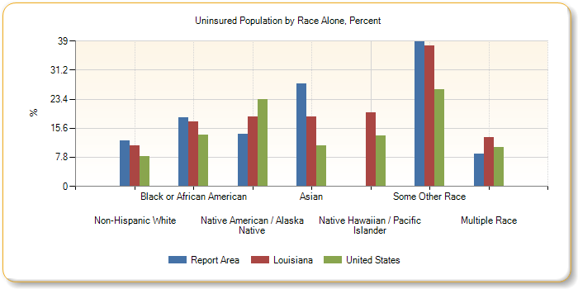
Uninsured Population by Race Alone, Total
Report Area | Non-Hispanic White | Black or African American | Native American / Alaska Native | Asian | Native Hawaiian / Pacific Islander | Some Other Race | Multiple Race
Report Area | 14,501 | 4,449 | 77 | 411 | 0 | 327 | 237
Acadia Parish | 6,827 | 1,955 | 6 | 0 | 0 | 277 | 102
Jeff Davis Parish | 2,581 | 929 | 14 | 14 | 0 | 4 | 42
Vermilion Parish | 5,093 | 1,565 | 57 | 397 | 0 | 46 | 93
Louisiana | 294,913 | 249,145 | 4,813 | 14,674 | 274 | 18,187 | 10,838
U. S. | 15,678,125 | 5,346,857 | 591,168 | 1,785,865 | 74,562 | 3,884,673 | 1,003,415
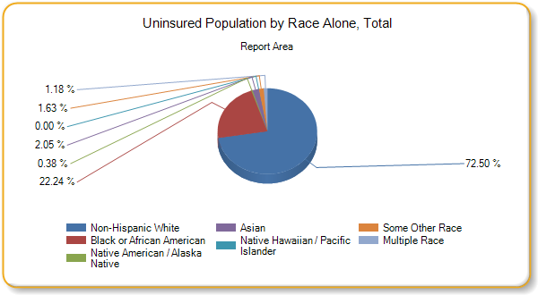
Poverty - Population Below 100% FPL
Poverty is considered a key driver of health status.
Within the report area 19.13% or 28,749 individuals are living in households with income below the Federal Poverty Level (FPL). This indicator is relevant because poverty creates barriers to access including health services, healthy food, and other necessities that contribute to poor health status.
Data Source: US Census Bureau, American Community Survey. 2012-16. | Percent Population in Poverty  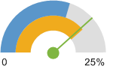  Report Area (19.13%)  Louisiana (19.7%)  United States (15.11%)
  Report Area | Total Population | Population in Poverty | Percent Population in Poverty
  Report Area | 150,257 | 28,749 | 19.13%
  Acadia Parish, LA | 61,011 | 12,579 | 20.62%
  Jefferson Davis Parish, LA | 30,683 | 6,020 | 19.62%
  Vermilion Parish, LA | 58,563 | 10,150 | 17.33%
  Louisiana | 4,514,625 | 889,570 | 19.7%
  United States | 310,629,645 | 46,932,225 | 15.11%

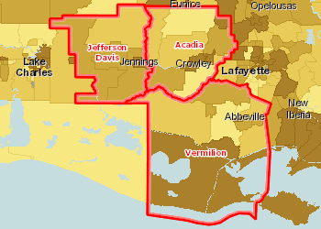 | Population Below the Poverty Level, Percent by Tract, ACS 2012-16  Over 20.0%  15.1 - 20.0%  10.1 - 15.0%  Under 10.1%  No Data or Data Suppressed  Report Area
Population in Poverty by Gender
Report Area | Total Male | Total Female | Percent Male | Percent Female
Report Area | 11,305 | 17,444 | 15.45% | 22.62%
Acadia Parish, LA | 4,626 | 7,953 | 15.55% | 25.43%
Jefferson Davis Parish, LA | 2,503 | 3,517 | 16.71% | 22.4%
Vermilion Parish, LA | 4,176 | 5,974 | 14.69% | 19.82%
Louisiana | 381,430 | 508,140 | 17.47% | 21.79%
United States | 21,012,839 | 25,919,386 | 13.82% | 16.34%
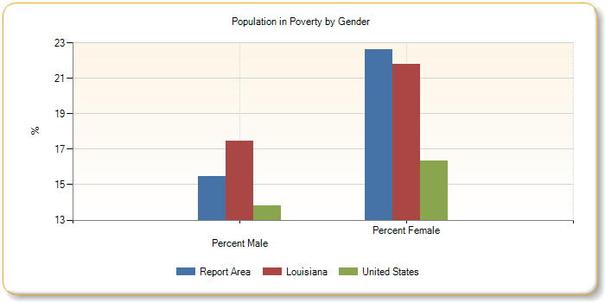
Population in Poverty by Ethnicity Alone
Report Area | Total Hispanic / Latino | Total Not Hispanic / Latino | Percent Hispanic / Latino | Percent Not Hispanic / Latino
Report Area | 1,082 | 27,667 | 28.59% | 18.89%
Acadia Parish | 344 | 12,235 | 27.45% | 20.47%
Jeff Davis Parish | 135 | 5,885 | 19.88% | 19.61%
Vermilion Parish | 603 | 9,547 | 32.56% | 16.83%
Louisiana | 49,071 | 840,499 | 22.72% | 19.55%
United States | 12,653,597 | 34,278,628 | 23.4% | 13.36%
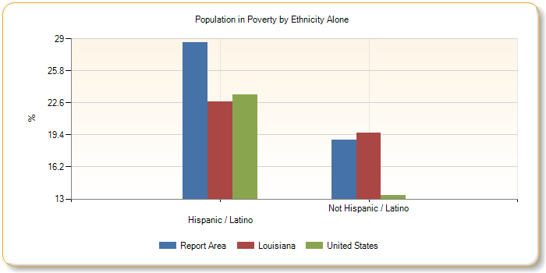
Population in Poverty Race Alone, Percent
Report Area | White | Black or African American | Native American / Alaska Native | Asian | Native Hawaiian / Pacific Islander | Some Other Race | Multiple Race
Report Area | 14.76% | 38.75% | 31.59% | 22.02% | 100% | 21.16% | 33.08%
Acadia | 15.2% | 43.81% | 37.04% | 0% | 100% | 24.77% | 28.02%
Jefferson Davis | 16.87% | 33.92% | 12.56% | 21.5% | no data | 0% | 17.51%
Vermilion | 13.23% | 35.11% | 44.23% | 22.54% | no data | 16.05% | 50.21%
Louisiana | 12.73% | 33.09% | 23.54% | 17.62% | 13.72% | 26.16% | 24.9%
U. S. | 12.44% | 26.22% | 27.59% | 12.33% | 20.07% | 25.37% | 19.27%
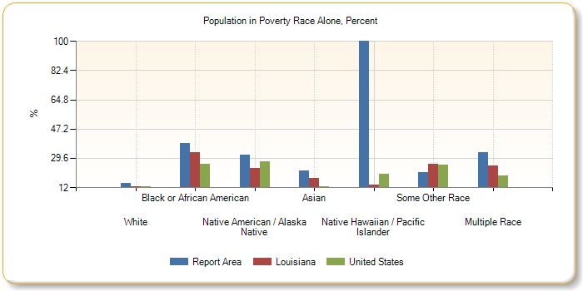
Population in Poverty by Race Alone, Total
Report Area | White | Black or African American | Native American / Alaska Native | Asian | Native Hawaiian / Pacific Islander | Some Other Race | Multiple Race
Report Area | 17,796 | 9,372 | 175 | 323 | 15 | 160 | 908
Acadia | 7,359 | 4,736 | 10 | 0 | 15 | 134 | 325
Jeff Davis | 4,157 | 1,699 | 27 | 23 | 0 | 0 | 114
Vermilion | 6,280 | 2,937 | 138 | 300 | 0 | 26 | 469
Louisiana | 362,341 | 474,354 | 6,049 | 13,640 | 191 | 12,565 | 20,430
U. S. | 28,424,685 | 10,111,248 | 692,998 | 2,009,019 | 108,956 | 3,765,448 | 1,819,871

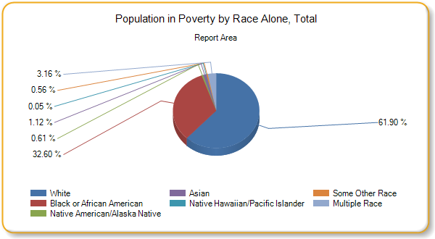
Teen Births
This indicator reports the rate of total births to women age of 15 - 19 per 1,000 female population age 15 - 19. This indicator is relevant because in many cases, teen parents have unique social, economic, and health support services. Additionally, high rates of teen pregnancy may indicate the prevalence of unsafe sex practices.
Data Source: US Department of Health Human Services, Health Indicators Warehouse. Centers for Disease Control and Prevention, National Vital Statistics System. Accessed via CDC WONDER. 2006-12. | Teen Birth Rate (Per 1,000 Population)  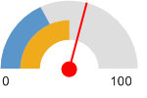  Report Area (58.45)  Louisiana (50.2)  United States (36.6)
  Report Area | Female Population  Age 15 - 19 | Births to Mothers Age 15 - 19 | Teen Birth Rate (Per 1,000 Population)
  Report Area | 5,441 | 318 | 58.45
  Acadia Parish, LA | 2,303 | 149 | 64.6
  Jefferson Davis Parish, LA | 1,156 | 64 | 55.6
  Vermilion Parish, LA | 1,982 | 105 | 52.9
  Louisiana | 161,032 | 8,084 | 50.2
  United States | 10,736,677 | 392,962 | 36.6

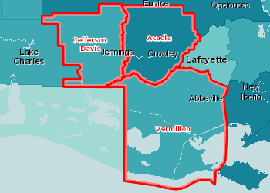 | Births to Females Age 15-19, Rate (Per 1,000 Pop.) by County, NVSS 2006-12  Over 60.0  45.1 - 60.0  30.1 - 45.0  Under 30.1  No Data or Data Suppressed  Report Area

Births to Women Age 15-19, Rate (per 1,000 Pop.) by Time Period,
2002-2008 through 2006-2012
Report Area | 2002-2008 | 2003-2009 | 2004-2010 | 2005-2011 | 2006-2012
Report Area | 60.28 | 60.28 | 59.55 | 58.81 | 58.45
Acadia Parish, LA | 65.2 | 66 | 65.2 | 64.5 | 64.6
Jefferson Davis Parish, LA | 60.6 | 58.8 | 55.9 | 55.5 | 55.6
Vermilion Parish, LA | 54.7 | 54.5 | 55.2 | 54.2 | 52.9
Louisiana | 53.8 | 53 | 52 | 50.7 | 50.2
United States | 41 | 40.3 | 39.3 | 38 | 36.6
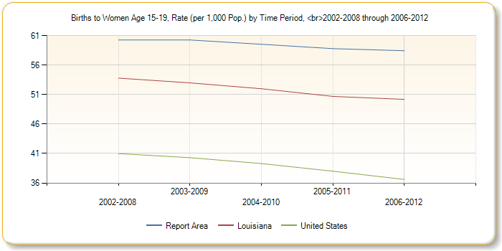
Births to Women Age 15-19, Rate (per 1,000 Pop.) by Race / Ethnicity
Report Area | Non-Hispanic White | Non-Hispanic Black | Hispanic or Latino
Report Area | 49.63 | 90.74 | no data
Acadia Parish, LA | 53.7 | 100.4 | 133.3
Jefferson Davis Parish, LA | 51.8 | 72.2 | no data
Vermilion Parish, LA | 44.2 | 89.6 | no data
Louisiana | 37.5 | 67.7 | 60.9
United States | 24.6 | 54.9 | 62
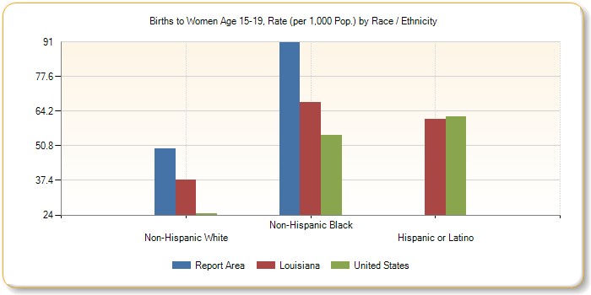
Unemployment Rate
Total unemployment in the report area for the current month was 4,064, or 6.4% of the civilian non-institutionalized population age 16 and older (non-seasonally adjusted). This indicator is relevant because unemployment creates financial instability and barriers to access including insurance coverage, health services, healthy food, and other necessities that contribute to poor health status.
Data Source: US Department of Labor, Bureau of Labor Statistics. 2018 - June. Source geography: County | Unemployment Rate  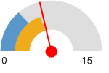  Report Area (6.4)  Louisiana (6.1)  United States (4.2)
  Report Area | Labor Force | Number Employed | Number Unemployed | Unemployment Rate
  Report Area | 63,039 | 58,975 | 4,064 | 6.4
  Acadia Parish | 24,470 | 22,839 | 1,631 | 6.7
  Jefferson Davis Parish | 13,847 | 13,008 | 839 | 6.1
  Vermilion Parish | 24,722 | 23,128 | 1,594 | 6.4
  Louisiana | 2,155,532 | 2,024,799 | 130,733 | 6.1
  United States | 164,383,283 | 157,469,839 | 6,913,444 | 4.2

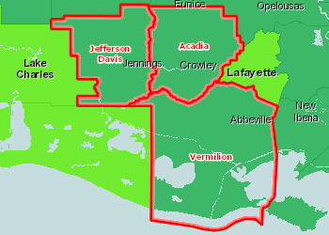 | Unemployment, Rate by County, BLS 2018 - June  Over 12.0%  9.1 - 12.0%  6.1 - 9.0%  3.1 - 6.0%  Under 3.1%  Report Area
Average Annual Unemployment Rate, 2006-2016
Report Area | 2006 | 2007 | 2008 | 2009 | 2010 | 2011 | 2012 | 2013 | 2014 | 2015 | 2016
Report Area | 3.2 | 3.3 | 3.8 | 6.2 | 7.3 | 6.8 | 6 | 5.9 | 5.7 | 6.8 | 7.2
Acadia Parish, LA | 3.2 | 3.3 | 3.8 | 6.3 | 7.3 | 6.7 | 6 | 6 | 5.8 | 6.8 | 7.4
Jefferson Davis Parish, LA | 3 | 3.1 | 3.6 | 5.6 | 7.5 | 7.2 | 6.5 | 6.2 | 5.9 | 6.2 | 6
Vermilion Parish, LA | 3.4 | 3.4 | 3.9 | 6.4 | 7.3 | 6.6 | 5.7 | 5.6 | 5.6 | 6.9 | 7.6
Louisiana | 3.9 | 3.8 | 4.4 | 6.6 | 8 | 7.8 | 7.1 | 6.7 | 6.4 | 6.3 | 6
United States | 4.7 | 4.7 | 5.8 | 9.3 | 9.7 | 9 | 8.1 | 7.4 | 6.2 | 5.3 | 4.9

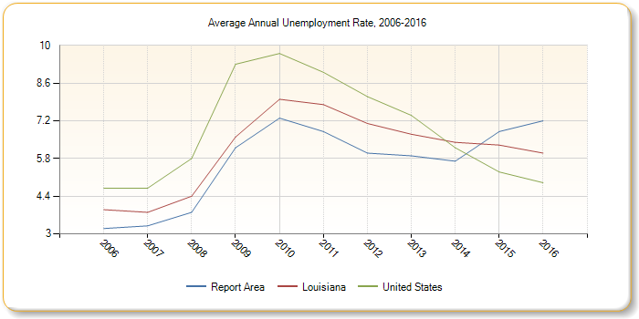
Physical Environment
A community’s health also is affected by the physical environment. A safe, clean environment that provides access to healthy food and recreational opportunities is important to maintaining and improving community health.
Housing - Substandard Housing
This indicator reports the number and percentage of owner- and renter-occupied housing units having at least one of the following conditions: 1) lacking complete plumbing facilities, 2) lacking complete kitchen facilities, 3) with 1.01 or more occupants per room, 4) selected monthly owner costs as a percentage of household income greater than 30%, and 5) gross rent as a percentage of household income greater than 30%. Selected conditions provide information in assessing the quality of the housing inventory and its occupants. This data is used to easily identify homes where the quality of living and housing can be considered substandard.
Data Source: US Census Bureau, American Community Survey. 2012-16. | Percent Occupied Housing Units with One or More Substandard Conditions  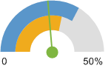  Report Area (23.71%)  Louisiana (29.36%)  United States (33.75%)
  Report Area | Total Occupied Housing Units | Occupied Housing Units with One or More Substandard Conditions | Percent Occupied Housing Units with One or More Substandard Conditions
  Report Area | 55,952 | 13,268 | 23.71%
  Acadia | 22,655 | 5,353 | 23.63%
  Jeff Davis | 11,554 | 3,175 | 27.48%
  Vermilion | 21,743 | 4,740 | 21.8%
  Louisiana | 1,731,398 | 508,265 | 29.36%
  U. S. | 117,716,237 | 39,729,263 | 33.75%

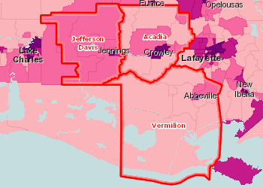 | Substandard Housing Units, Percent of Total by Tract, ACS 2012-16  Over 34.0%  28.1 - 34.0%  22.1 - 28.0%  Under 22.1%  No Data or Data Suppressed  Report Area
Substandard Housing: Number of Substandard Conditions Present
Report Area | No Conditions | One Condition | Two or Three Conditions | Four Conditions
Report Area | 76.29% | 22.31% | 1.4% | 0%
Acadia Parish, LA | 76.37% | 22.32% | 1.31% | 0%
Jefferson Davis Parish, LA | 72.52% | 26.23% | 1.25% | 0%
Vermilion Parish, LA | 78.2% | 20.21% | 1.59% | 0%
Louisiana | 70.64% | 28.14% | 1.21% | 0%
United States | 66.25% | 31.75% | 1.99% | 0.01%
Substandard Housing: Households Lacking Complete Plumbing Facilities
Complete plumbing facilities include: (a) hot and cold running water, (b) a flush toilet, and (c) a bathtub or shower. All three facilities must be located inside the house, apartment, or mobile home, but not necessarily in the same room. Housing units are classified as lacking complete plumbing facilities when any of the three facilities is not present.
Report Area | Total Occupied Housing Units | Housing Units Lacking Complete Plumbing Facilities | Housing Units Lacking Complete Plumbing Facilities, %
Report Area | 55,952 | 328 | 0.59%
Acadia Parish | 22,655 | 71 | 0.31%
Jeff Davis Parish | 11,554 | 50 | 0.43%
Vermilion Parish | 21,743 | 207 | 0.95%
Louisiana | 1,731,398 | 6,611 | 0.38%
United States | 117,716,237 | 463,649 | 0.39%
Substandard Housing: Households Lacking Complete Kitchen Facilities
A unit has complete kitchen facilities when it has all three of the following facilities: (a) a sink with a faucet, (b) a stove or range, and (c) a refrigerator. All kitchen facilities must be located in the house, apartment, or mobile home, but they need not be in the same room. A housing unit having only a microwave or portable heating equipment such as a hot plate or camping stove should not be considered as having complete kitchen facilities. An icebox is not considered to be a refrigerator.
Report Area | Total Occupied Housing Units | Housing Units Lacking Complete Kitchen Facilities | Housing Units Lacking Complete Kitchen Facilities, Percent
Report Area | 65,332 | 3,330 | 5.1%
Acadia Parish | 25,867 | 1,493 | 5.77%
Jeff Davis Parish | 13,596 | 623 | 4.58%
Vermilion Parish | 25,869 | 1,214 | 4.69%
Louisiana | 2,011,700 | 82,505 | 4.1%
United States | 134,054,899 | 3,806,611 | 2.84%
Clinical Care
A lack of access to care presents barriers to good health. The supply and accessibility of facilities and physicians, the rate of un-insurance, financial hardship, transportation barriers, cultural competency, and coverage limitations affect access.
Rates of morbidity, mortality, and emergency hospitalizations can be reduced if community residents access services such as health screenings, routine tests, and vaccinations. Prevention indicators can call attention to a lack of access or knowledge regarding one or more health issues and can inform program interventions.
Access to Primary Care
This indicator reports the number of primary care physicians per 100,000 population. Doctors classified as "primary care physicians" by the AMA include: General Family Medicine MDs and DOs, General Practice MDs and DOs, General Internal Medicine MDs and General Pediatrics MDs. Physicians age 75 and over and physicians practicing sub-specialties within the listed specialties are excluded. This indicator is relevant because a shortage of health professionals contributes to access and health status issues.
Data Source: US Department of Health Human Services, Health Resources and Services Administration, Area Health Resource File. 2014. Source geography: County | Primary Care Physicians, Rate per 100,000 Pop.  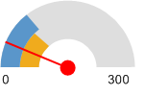  Report Area (37.1)  Louisiana (78.7)  United States (87.8)
  Report Area | Total Population, 2014 | Primary Care Physicians, 2014 | Primary Care Physicians, Rate per 100,000 Pop.
  Report Area | 153,579 | 57 | 37.1
  Acadia Parish | 62,486 | 23 | 36.81
  Jeff Davis Parish | 31,477 | 14 | 44.48
  Vermilion Parish | 59,616 | 20 | 33.55
  Louisiana | 4,649,676 | 3,660 | 78.7
  U. S. | 318,857,056 | 279,871 | 87.8

SWOT Analysis: Strengths, Weaknesses, Opportunities, Threats
Additional assessment of the agency was gathered utilizing SWOT (Strengths, Weaknesses, Opportunities, Threats) Analysis. Strengths and Opportunities are the positive Enablers for the Agency’s work, while Weaknesses and Threats are Challenges that must be addressed in order for the Agency to achieve its strategy. The SWOT Analysis includes both internal (Strengths and Weaknesses) and external (Opportunities and Threats) factors.

SWOT Analysis

Internal
Strengths | Weaknesses
- Leader in the Community  - Strong Partnerships and Collaborations  - Strong Board and Executive Leadership  - Fiscally Responsible  - Low Staff Turnover  - Board/Staff Commitment to Mission  - Diversity of Programs | - Outdated Technology & Software  - Employee Cross-Training  - Lack of Follow-up  - Lack of Board Training  - Staff Resistance to Change  - Slow to Implement Case Management

External
Opportunities | Threats
- Development of Affordable Housing  - Partnerships with Untapped Entities  - Case Management  - Other Funding Sources  - New Homeless Shelter  - Enhance Employee Development  - Expand Marketing Effort  - Educate Legislators  - Break Cycle of Poverty | - Uncertainty of Federal Funding Sources  - Lack of State Funding  - Continual Slow Economic Recovery  - Growth of Low-Income Population  - Demand for Emergency Services  - Changing Political Climate
Results-Oriented Management and Accountability

In 1994, the Federal government produced a National Strategic Plan endorsing a “results-oriented management and accountability” approach for Community Action Agencies, which became known as ROMA. Throughout the strategic planning process, the agency based its objectives upon the principles contained in the ROMA framework for continuous growth and improvement.

The Six National ROMA Goals

(Representing three levels of results – Family, Community & Agency)

Goal 1 Low-income people become more self-sufficient. Family

Goal 2 The conditions in which low-income people live are improved. Community

Goal 3 Low-income people own a stake in their community. Community

Goal 4 Partnerships among supporters and providers of services to low-income people are achieved. Agency

Goal 5 Agencies increase their capacity to achieve results. Agency

Goal 6 Low-income people, especially vulnerable populations, achieve their potential by strengthening family and other supportive systems. Family


In the CSBG Act of 1998, ROMA was amended, mandating a comprehensive performance-based management system defined as: “a sound management practice that incorporates the use of outcomes or results into the administration, management, and operation of community action agencies.”

In 2006, the ROMA Cycle guide for a results-oriented planning process was created, “Planning for Results.” This ROMA Cycle included the following activities: Assessment, Planning, Implementation, Achievement of Results, and Evaluation. The ROMA system now incorporates the six national goals into the agencies performance management process as follows:

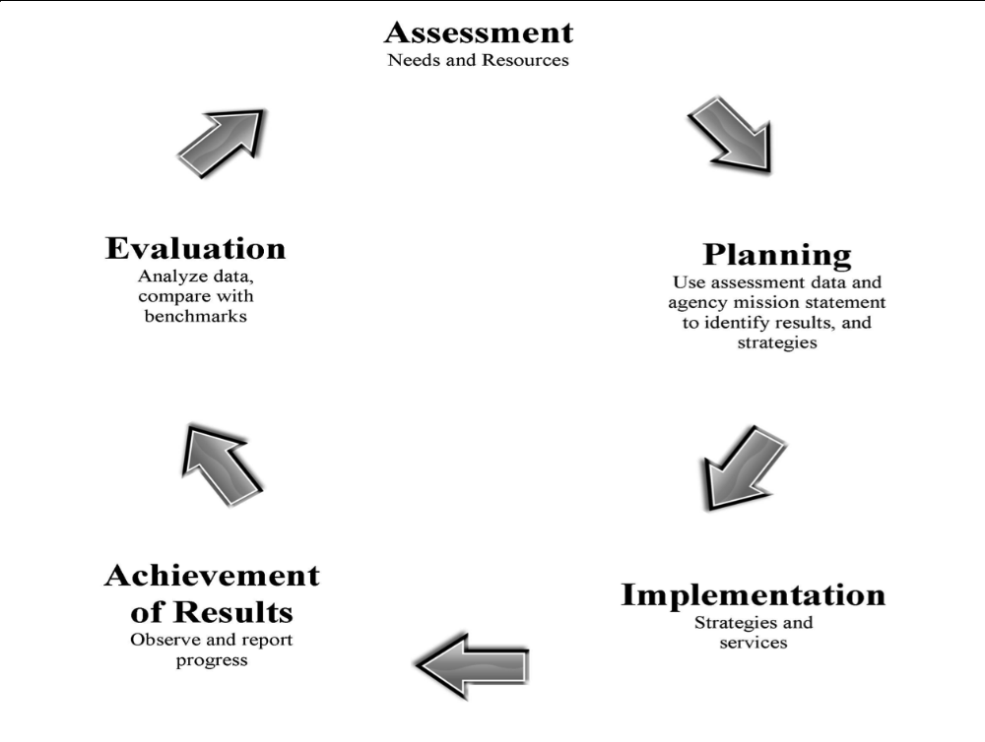

National Performance Indicators

After establishing mandatory performance reports in 2001, the Federal Office of Community Service created a standard system of reporting Community Action Agency results called the National Performance Indicators (NPIs). The NPI report is the “accountability” portion of the ROMA cycle and is monitored by OCS.

Logic Model

Many funders in their Request for Proposals require applicants to create a Logic Model which links between community needs, services, outcomes and measurement of results. A Logic Model specifically designed for CAA follows the following steps:

Logic Model | Problem Statement | Service or Activity | Outcome | Outcome Indicator | Action Results | Measurement Tool | Data Source | Frequency of Data Collection

To accomplish these goals, the ASSIST Agency has been encouraged to undertake a number of ROMA implementation actions that focus on results-oriented management and results-oriented accountability:

Results-Oriented Management

- Assess poverty needs and conditions within the community
- Define a clear agency anti-poverty mission for community action and a strategy to address those needs, both immediate and longer term, in the context of existing resources and opportunities in the community.
- Identify specific improvements or results to be achieved among low-income people and the community and
- Organize and implement programs, services, and activities, such as advocacy, within the agency and among partnering organizations to achieve anticipated results.

Results-Oriented Accountability

- Develop and implement strategies to measure and record improvements in the condition of low-income people and the communities in which they live that results from community action intervention;
- Use information about outcomes, or results, among the agency’s tripartite board and staff to determine the overall effectiveness, inform annual and long-range planning, support agency advocacy, funding, and community partnership activities.

Organizational Profile

Established in 1967 as Acadia- Vermillion Community Action Program (AVCAP), the organization grew from a small community-based program with a focus on providing solutions to poverty, to at one point, multiple programs, million plus dollar budget, the inclusion of Jefferson Davis Parish in 1981, to now fewer programs and a smaller budget and new leadership. What has been key through these changes and challenges has been the commitment by staff, board, and community stakeholders in three parishes to strive for a solution to poverty. The culture of the organization is such that they clearly identify with the concept of providing a hand up as a solution, not a hand out.

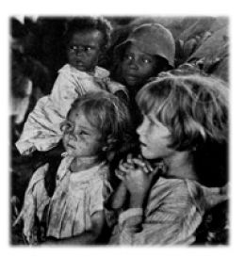
AVCAP/ASSIST Agency, Inc. is a community action agency with its heritage drawn from funding provided from the Economic Opportunity Act of 1964. No two CAA’s in the United States are alike and there are no typical CAA’s. But despite this fact, there is a typical CAA approach to fighting the causes of poverty. Local agencies approach these goals by offering a variety of programs that serve low income children, families, and seniors. They coordinate emergency assistance, provide weatherization services, sponsor youth programs, operate senior centers, and provide transportation in rural areas. CAA’s provide linkages to job training opportunities, GED preparation courses, and vocational education programs. They provide a range of services addressing poverty related problems – from income management and credit counseling to entrepreneurial development and small business incubators; from domestic violence crisis assistance to family development programs and parenting classes; and, from food pantries and emergency shelters to low income housing development and community revitalization projects.

The term ASSIST in the agency’s new name is an acronym representing A Self-Sufficiency Improvement Support Team and the new name came about after 1992 and a change in organizational leadership.

The staff and Board are committed to the tagline that greets guests and clients at the front door- Helping People-Changing Lives. Both groups repeated stories about times that they have come together as a team to do just that- help people and change lives, particularly during recent disasters. These key perspectives shape the core values of the organization, its position in the community, and its leadership. While the organization has struggled at times with the loss of programs, changes in staff, and changes in funding mechanisms, it is an organization that expresses through its culture that it will continue to help people.

Mission


The mission of ASSIST Agency, Inc. is to elevate the standard of living and improve the quality of life for low-income families and communities in Southwest Louisiana.

Philosophy

People can help themselves if given a helping hand and not a handout.

Vision

To have the public trust and be recognized as a leader in helping to empower people in becoming more self-sufficient and to help in strengthening local communities in becoming more responsive to the needs of the people.

Position And Core Values Statement

ASSIST Agency, Inc. supports the development of a national policy that ensures that:
- Everyone who can work should work.
- Those who do work should earn sufficient income to provide for their families’ basic needs.
- Those who are unable to work or who work but do not earn enough to provide for their families should be assisted by policies and programs to meet their basic needs and secure safe and decent housing.

Tagline

Helping People - Changing Lives
Assumptions

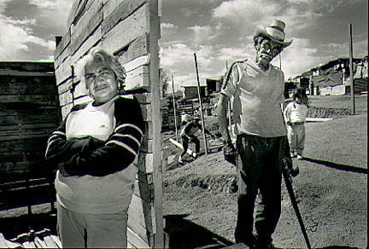
ASSIST Agency, Inc. is committed to providing services to low-income families and the communities of Southwest Louisiana including the parishes of Jefferson Davis, Acadia and Vermillion. During the strategic conversations, participants were asked to delineate what services from the list below best identified as being the core services for ASSIST. The collective conversations identified housing services as the primary service and those related services, marked in italics as key to meeting the mission of ASSIST for Jefferson Davis, Acadia and Vermillion Parishes. Other services provided are vital, community-based, and reflect the changing needs of each community within the scope of the organization. Each CAA is funded through Community Services Block Grant (CSBG) funds which are considered innovative concept funds in that they give CAA’s the flexibility to design programs that address needs specific to individuals and the local community and to identify specialized resources that fit these needs.

Services
- Affordable Housing
- Medicaid/LA Chip/Part D Application Assistance
- Prescription Medication Help
- Emergency Food, Utilities, and Rental Assistance
- Food Vouchers for Families
- Summer Feeding Program
- Revolving Loan Applications
- Outreach and Referral (Employment services)
- Homeless Shelter for Women and Children
- VITA Tax Assistance (seasonal)
- Toys for Tots
- IDA
- Housing and Financial Counseling

Accountability

The Executive Director of the ASSIST Agency is responsible for ensuring that all Strategic Plan goals are met. Additionally, other staff members have been assigned the task of ensuring that specific goals are met as well.
GOAL ONE Consumer Input and Involvement

The ASSIST Agency will engage people with low incomes in a coordinated and comprehensive manner to develop programs and services that will make a critical difference in the lives of participants.

Objective | Accountability | Timeline

The ASSIST Agency will involve low-income individuals in its community activities, such as board governance, volunteering, and other participatory means so that they are able to move themselves and their families out of poverty. | BOD, ED,  CSD, PBD | STO
The agency will analyze information collected directly from low-income individuals as part of its on-going Community Assessment. | BOD, ED,  PBD | STO
The agency will implement a systematic approach for collecting, analyzing, and reporting customer satisfaction data to the governing board. | ED, CSD,  PBD | STO
The agency will use the information gathered to identify current gaps in service delivery and program evaluation to ensure program quality and effectiveness. | ED, CSD,  PBD | AO

.

GOAL TWO Community Engagement

The ASSIST Agency will successfully move families out of poverty and revitalize communities through formal and informal partnerships from community and faith-based organizations, educational institutions, government, and business, ongoing community planning, advocacy, and engagement of people with low incomes.

Objective | Accountability | Timeline

The partnerships that the agency has cultivated, especially those that are anti-poverty focused, will be documented and/or demonstrated. | ED, PBD | AO
The agency will utilize information gathered from community-based organizations, faith-based organizations, private sector, public sector, and educational institutions in assessing the community needs and resources. | BOD, ED,  PBD | AO
The agency will communicate to community, volunteers, and donors the value of the services provided by ASSIST Agency through printed materials, internet and media. | BOD, ED, CSD | AO
Establish collaborations with community partners in order to facilitate a simultaneous access to agencies, information, and create a forum to share viable solutions to issues and problems. | ED, CSD,  PBD | AO
Continue membership(s) and participation in a minimum of three strategic areas: Community Outreach, Homelessness, and Housing | ED, CSD,  HD, PBD | AO
Conduct presentations, directly or virtually, to outside groups in showcasing the agency’s programs and leadership in poverty reduction. | ED, CSD,  HD, PBD | AO
The agency will engage and enhance the service delivery system to those in the rural areas we serve. | ED, CSD,  HD, PBD | AO

GOAL THREE Community Assessment

Regular assessment of needs and resources at the community level is a vital management and leadership tool. Regular comprehensive Community Assessments that take into account the breadth of the community needs as well as the partners and resources available to meet these needs must be utilized by the agency in determining how best to meet those needs.

Objective | Accountability | Timeline

The ASSIST Agency will conduct a Community Assessment and issue a report. | BOD, ED, CSD, PBD | MTO
The agency will collect data specific to poverty and its prevalence related to gender, age, and race/ethnicity for the three parish area. | ED, CSD,  PBD | AO
Qualitative and quantitative data on the three parish area will be collected and analyzed and incorporated into the Community Assessment. | ED, PBD | MTO
The governing board of directors will formally accept the completed Community Assessment. | BOD | MTO
Develop a consensus building, tabling model to assess organizational and staff capacity prior to adding additional programs. This must include board and community stakeholders’ involvement. | BOD, EXS | AO

GOAL FOUR Organizational Leadership

Maintain a position as the community-based organization whose responsiveness is nimble enough to respond with teamwork to events that impact the community they serve, both today and into the future. The agency leadership is exemplified at all levels of the organization, from a well-functioning board to a focused Executive Director to a well-trained and dedicated staff.

Objective | Accountability | Timeline

The governing board of directors will review the ASSIST Agency’s Mission Statement to assure that it addresses poverty and that the agency’s programs and services are all in alignment with the mission. | BOD | STO
The Community Action Plan of the agency is outcome-based, anti-poverty focused, and ties directly to the Community Assessment. | BOD, ED,  PBD | AO
The Community Action Plan and the Strategic Plan documents the full use of the ROMA cycle. | BOD, ED,  PBD | STO
ASSIST will have in place a Board-approved succession plan for the position of Executive Director. | BOD, ED | STO
The agency will conduct an organization-wide risk assessment and present to the governing board of directors for acceptance. | ED, FD | MTO
Investigate the SWOT (Strengths, Weaknesses, Opportunities, Threats) Analysis, Continuous Quality Improvement (CQI), and Total Quality Management (TQM) Models for agency evaluation that both clients and employees would benefit from in order to improve the function of the workplace. | BOD, EXS | LTO

GOAL FIVE Board Governance

In the face of increased competition, the Board of Directors will accept the challenge of increasing its effectiveness and maintain a position as a community-based organization whose responsiveness is nimble enough to respond with teamwork to events that impact the community they serve. The board objectives include: providing leadership in efforts toward providing solutions to poverty; fostering collaboration to improve the community; building community capacity through innovative culturally competent strategies and by achieving impact by acting as a catalyst for positive change.

Objective | Accountability | Timeline

The agency will ensure that the governing board is structured in compliance with the CSBG Act, that at least one third have been democratically-selected and documented to represent the low-income community, and meets in accordance with the frequency and quorum requirements and fills board vacancies as set out in the bylaws. | BOD, ED,  PPR | AO
The agency’ bylaws have been reviewed by an attorney within the past 5 years. | BOD, ED,  PPR | LTO
Documented that each governing board member has received a copy of the bylaws | ED, PPR | STO
Each governing board member has signed a conflict of interest policy. | ED, PPR | STO
Develop a board orientation manual and a policy of deepening board engagement during the new board member recruitment process. This would include inviting prospective members to an actual board meeting. | BOD, ED,  PPR | STO
Board members will participate in governance training to better understand the relationship between policy making and management and will review their specific fiduciary duties of care, loyalty, and obedience to the law during board training and presentations on ROMA concepts and bylaws. | BOD, ED | AO
The Board of Directors, as a tripartite board, will bring together representatives of the private sector, public sector, and low-income community to collaborate on developing responsiveness to local needs in order to develop a long-term community needs assessment. | BOD, ED,  PBD | STO
The governing board members will receive, review and approve all programmatic reports at each regular board meeting. | BOD | STO

GOAL SIX Strategic Planning

Strategic Planning takes on the task of looking both at internal functioning and at the community’s needs. For the agency to be efficient, it needs to know where it is headed, how the board and staff fit into that future, and how it will measure its success in achieving what it has set out to do.

Objective | Accountability | Timeline

The agency will have an agency-wide Strategic Plan which has been approved by the governing board of directors within every five years. | EXS | LTO
The agency will address reduction of poverty, revitalization of low-income communities, and empowerment of people with low incomes to become more self-sufficient in the approved Strategic Plan. | BOD, EXS | AO
The approved Strategic Plan contains Family, Agency, and/or Community goals as well as customer satisfaction data and input as part of the Community Assessment. | BOD | LTO
When and if disaster strikes in our communities, the ASSIST Agency will examine its role in the long term recovery process through organizations such as VOAD and LTRC. | BOD, ED,  PBD | AO
Review the staff/space relationship of existing and future programs, against the availability of property within the three parish region in order to prepare a growth plan for the organization. | EXS | AO
Identify and develop new programs that engage a diverse changing community which includes expanding minority populations. | BOD, EXS | AO
The agency will explore with LA Housing Corp subcontracting LiHEAP services in Acadia and Jefferson Davis Parish to improve service delivery to its residents. | BOD, EXS | LTO
The agency will seek out new programs to increase the populations’ access to banking and credit unions. | ED, CSD,  PBD | MTO
The governing board of directors will receive updates on meeting the Strategic Plan. | ED | AO

GOAL SEVEN Human Resource Management

Attention by the agency to organizational elements such as policies and procedures, performance appraisals, and training lead to a strong organization with the capacity to deliver high-quality services in low-income communities.

Objective | Accountability | Timeline

The agency’s written personnel policies will be reviewed by an attorney and approved by the governing board of directors | ED, PPR | LTO
The agency’s written job descriptions will be reviewed and updated. | ED, PPR | LTO
The governing board of directors will conduct a performance appraisal of the Executive Director within each calendar year. | BOD | AO
The agency will develop a staff development work plan which includes regularly scheduled opportunities for professional development of staff members, opportunities for attendance at off-site trainings, webinars, team building activities, and participation in cross-training meetings. | EXS | STO
The agency will designate who will act on behalf of key staff members in their absence. | ED | AO
GOAL EIGHT Financial Operations and Oversight

The ASSIST Agency and staff maintain a high level of fiscal accountability through audits, monitoring by State and Federal agencies, and compliance with Federal Office of Management Budget circulars (OMB Circular A-133). The management of Federal funds is taken seriously in the day-to-day operational functions by agency staff and the oversight role of the governing board of directors.

Objective | Accountability | Timeline

At each regular board meeting, the governing board of directors will receive financial reports that include organization-wide reports on Revenue and Expenditures, categorized by programs and Balance Sheet/Statement of Financial Position. | ED, FD | STO
The governing board of directors will annually approve an organization-wide budget. | ED, FD,  PBD | AO
The Fiscal Policies will be reviewed by the staff, updated as necessary, with changes approved by the governing board of directors. | ED, FD | MTO
A written procurement policy is in place and will be reviewed by the governing board of directors. | ED, FD | LTO
The agency will document and/or update how it allocates shared costs through an indirect cost rate, or through a written cost allocation plan. | ED, FD,  PBD | STO
The agency will implement and/or update a written policy in place for record retention and destruction. | ED, PPR | AO

GOAL NINE Technology and Data Analysis

The ASSIST Agency works to move families out of poverty on a daily basis and produces data that reflects the collective impact of these efforts. The agency strives to better document the outcomes of individuals, families, communities, and other agency achievements.

Objective | Accountability | Timeline

CAP60, ServicePoint and HCO will be utilized to its full potential to track and report services customers receive and their outcomes. | ED, CSD,  PBD | STO
The agency will improve the accuracy and timelines of the information entered into CAP60 and ServicePoint. | ED, CSD | STO
The agency will research and assess community data in partnership with SLCC, ULL, ARDD, and others with the specific purpose of identifying future trends for serving low income children, families, and seniors, to support agency marketing/public relations functions and Strategic Planning. | ED, CSD,  PBD | AO
Develop a mechanism for supporting existing administrative technology which will allow staff to work efficiently without being totally reliant upon one funder for hardware repairs and installation or software upgrades. | ED, CSD,  PBD | AO
Provide and expand a range of services addressing housing related problems – from Individual Development Accounts and housing counseling to housing development and housing rehabilitation to foreclosure prevention and CHDO related activities such as a HOME funded project. | ED, HD | STO

Legend

Abbreviations

ARCH Acadiana Regional Coalition on Homelessness & Housing

BOD Board of Directors

CHDO Community Housing Development Organization

CSBG Community Services Block Grant

CSD Community Services Director

ED Executive Director

EF&S Emergency Food & Shelter program

ESC Eligibility/Service Coordinators

ESG Emergency Solutions Grant

EXS Executive Staff

FD Fiscal Director

HD Housing Director

HPRP Homeless Prevention & Rapid Re-Housing Program

LTRC Long Term Recovery Coalition

PBD Planning & Budget Director/EO Officer

PPR Personnel/Physical Resource Officer

ROMA Results Oriented management and Accountability

UWA United Way of Acadiana

UWSWLA United Way of Southwest Louisiana

VOAD Volunteer Organizations Active in Disasters

WIA Workforce Investment Act

Timeline
STO Short-term Objective (< 1 year)
MTO Medium-term Objective (1 – 3 years)
LTO Long-term Objective (up to 5 years)
AO Annual Objective (addressed on an annual basis)

Summary

The ASSIST Agency has a rich heritage of working closely with the communities in Acadia, Jefferson Davis and Vermillion parishes since 1967. The strength of the organization lies in the collective experience of its Executive Director and staff as well as the commitment of key members of the Board of Directors. But in order for this to translate to a strong future for the organization, bold steps must be taken by those same stakeholders. The promise of any community action agency is to change people’s lives, embody the spirit of hope, improve communities, and make America a better place to live.

The ASSIST Agency is well positioned to provide immediate and tangible impacts to the individuals, families, and communities that the agency serves. Using the planned goals laid out in this Strategic Plan as a guide, the board of directors and management of the ASSIST Agency will be able to develop measurable, effective goals to meet the long term strategic vision of the organization.
It is up to the ASSIST board, staff, and volunteers to work within the areas they know best to find solutions to fight poverty now and in the future. The results of implementing and achieving these goals will be felt by each family lifted up from and out of poverty for generations to come.

